

**Project Name:** Result Management System.

Under the guidance of

**Dr. Sheak Rashed Haider Noori**

**Associate Professor and Associate Head**  
Department of Computer Science and Engineering

Faculty of Science and Information Technology

Acknowledgement

LAB PREFECT 1 : [Rahat Islam Srijon](https://www.facebook.com/profile.php?id=100008999868860&__tn__=%2Cd-%5D-p-R&eid=ARDSLh2j3oDLfkXo_y36DnHLpT8_Da40yntHik2g8iuus71qmrh99b0EHCRwJj0aRym-hWD_WhzSNeJv&hc_location=friend_browser&fref=fc_pymk)

LAB PREFECT 2 : [Shimul Sutradhar](https://www.facebook.com/profile.php?id=100023888747050&ref=br_rs)

# Team Members:

1. Md. Mahfuzur Rahman (193-15-13416)
2. Md. Abdullah Ibna Harun (193-15-13426)
3. Mahade Hasan forhad (193-15-13355)
4. Abidur Rahman Khan (193-15-13374)

Section : A

Batch : 54

Semester : Spring 2020

# Project Details:

* Home Menu: This is our Home Page.

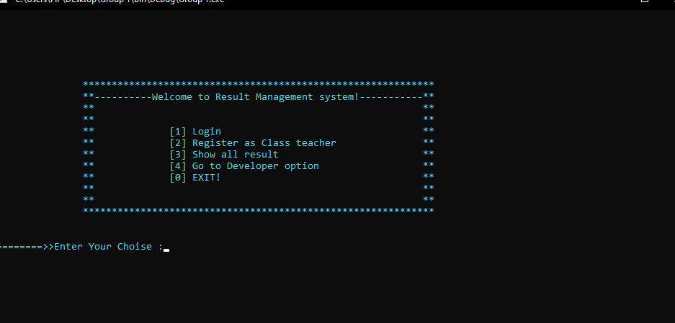

* Register as Class Teacher: In this feature a teacher can easily register our project by providing his First Name, Last Name, email address, Username and Password.



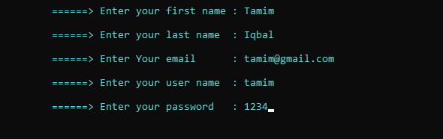

* Log in: we provides this feature for our security concern. In this feature User can not access or can not go our project Main menu without Register username and password.

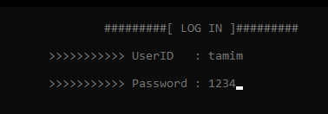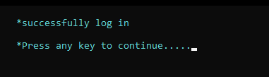

* Published Result: After log in a teacher can see all students result, which result he published .

* Entry Result: After log in ,A teacher can easily entry students result by his name and Roll number.

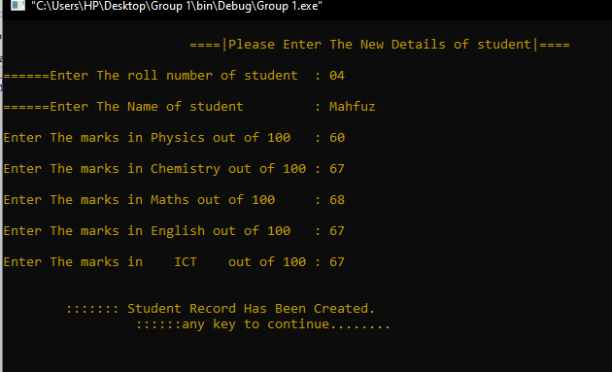

* Log out: After Publishing the result a teacher can log out his account.

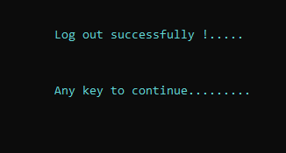

* Show All Result: Our project provides the students results. For that reason we have some concern for students. We used this option for as an alternative for result notice board. In this option, Students Can see their result without any kind of registration or log in.

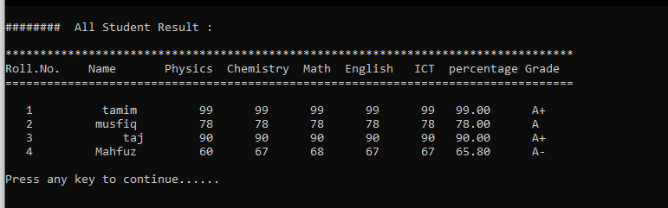

* Developer Option: Meet our project Developer ,there you can find their all information.

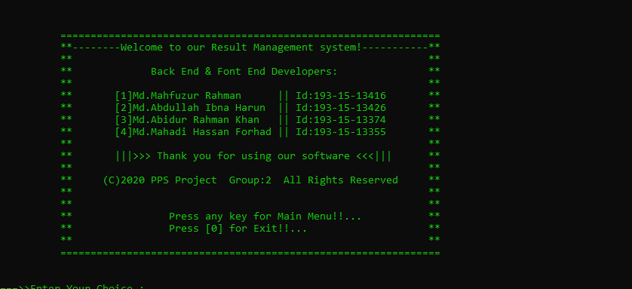

* File: We also use File for store our customer registration information and as a back up we also store students results in our file.

Register information

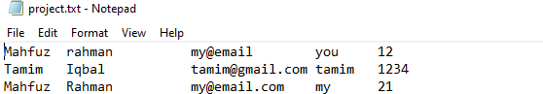

Student Results:

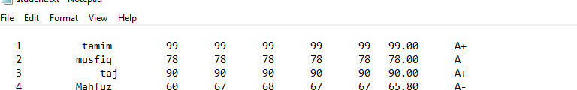

-------- Thank You ------